**LAB-02**

**Basic javscript**

**OBJECTIVE:-**

**To get familiar with JS Basics.**

**TASK 01 CODE:**

**Html :**

<!DOCTYPE html>

<html lang="en">

<head>

    <script src="web.js"></script>

    <meta charset="UTF-8">

    <meta http-equiv="X-UA-Compatible" content="IE=edge">

    <meta name="viewport" content="width=device-width, initial-scale=1.0">

    <title>Instagram</title>

    <link rel="stylesheet" href="lab2.css">

</head>

<body id="qwerty1">

<div class="form1">

    <h1 id="log1">ACCOUNT LOGIN</h1>

    <form>

        <label >USERNAME</label>

        <br><br>

        <input type="text" class="user1">

        <br><br>

        <label >PASSWORD</label>

        <br><br>

        <input type="password" class="password1">

        <br><br>

        <input type="button" value="OK" class="fail1" onclick=" Ok()">

        <br><br>

        <input type="button" value="CANCEL" class="fail1" onclick="Cancel()">

    </form>

</div>

</body>

</html>

**Css:**

#log1{

    color: rgb(33, 82, 243);

    padding-left: 0px;

    padding-top: 30px;

}

#qwerty1{

    background-color:rgb(0,204,255);

}

.form1{

    width: 450px;

    height: 450px;

    border:5px solid black;

    padding-left: 50px;

    background-color: white;

    margin-left: 450px;

    margin-top: 60px;

    border: none;

}

.fail1{

    width: 400px;

    height: 30px;

    background-color: rgb(51,102,255);

    border: none;

    color: white;

}

.user1{

    width: 400px;

    height: 30px;

}

.password1{

    width: 400px;

    height: 30px;

}

**Javascript :**

function Ok(){

    alert("Ok is Clicked")

}

function Cancel(){

    alert("Cancel is Clicked")

}

**RESULT:-**

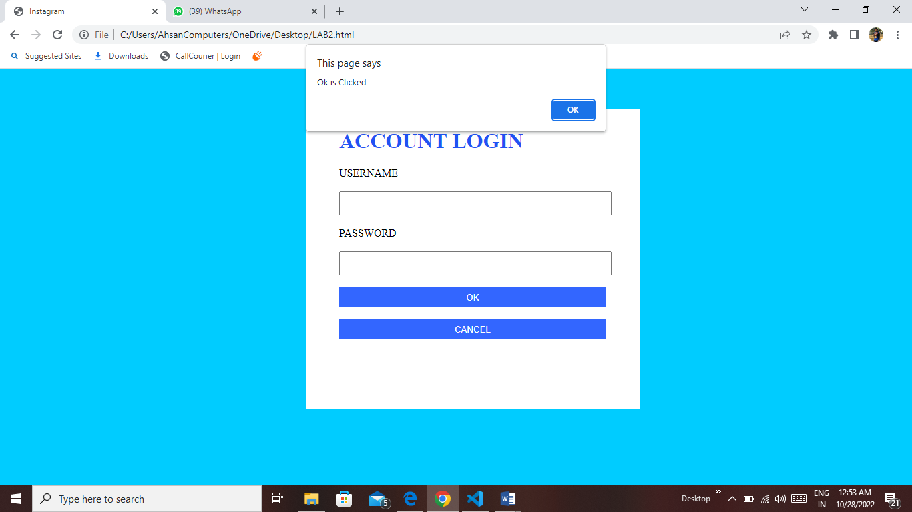

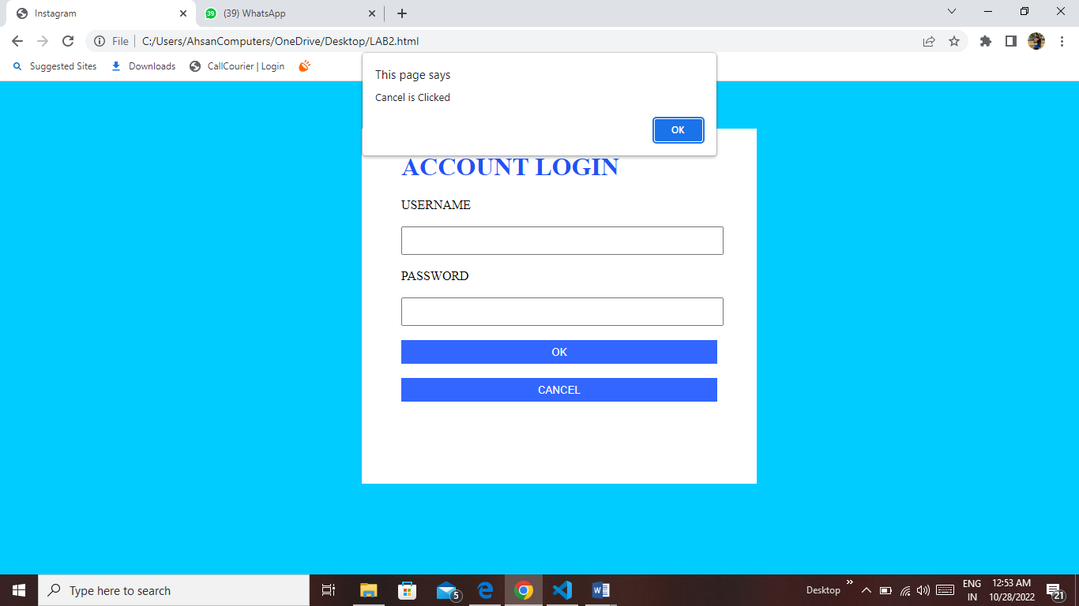

**TASK 02 CODE:**

<!DOCTYPE html>

<html lang="en">

<head>

    <script src="task2.js"></script>

    <meta charset="UTF-8">

    <meta http-equiv="X-UA-Compatible" content="IE=edge">

    <meta name="viewport" content="width=device-width, initial-scale=1.0">

    <title>Instagram</title>

    <link rel="stylesheet" href="lab2 task 2.css">

</head>

<body id="qwerty1">

    <img src="C:\Users\AhsanComputers\OneDrive\Desktop\images/fb1.png" title="img not found">

    <img src="C:\Users\AhsanComputers\OneDrive\Desktop\images/icon1.png" title="img not found">

    <img src="C:\Users\AhsanComputers\OneDrive\Desktop\images/icon3.png" title="img not found" >

    <img src="C:\Users\AhsanComputers\OneDrive\Desktop\images/icon4.png" title="img not found" >

<div class="form1">

    <h1 id="log1">ACCOUNT LOGIN</h1>

    <form>

        <label >USERNAME</label>

        <br><br>

        <input type="text" class="user1">

        <br><br>

        <label >PASSWORD</label>

        <br><br>

        <input type="password" class="password1">

        <br><br>

        <input type="checkbox" >Remember me

        <p class="pass1">forgot password ?</p>

        <input type="button" value="OK" class="fail1" onclick=" Ok()">

        <br><br>

        <input type="button" value="CANCEL" class="fail1" onclick="Cancel()">

        <br><br>

        <input type="button" value="LOGIN" class="fail1" onclick="login()">

    </form>

</div>

</body>

</html>

**CSS:**

#log1{

    color: rgb(33, 82, 243);

    padding-left: 0px;

    padding-top: 30px;

}

#qwerty1{

    background-color:black;

}

.form1{

    width: 450px;

    height: 450px;

    border:5px solid black;

    padding-left: 50px;

    background-color: white;

    margin-left: 450px;

    margin-top: 60px;

    border: none;

}

.fail1{

    width: 400px;

    height: 30px;

    background-color: rgb(51,102,255);

    border: none;

    color: white;

}

.user1{

    width: 400px;

    height: 30px;

}

.password1{

    width: 400px;

    height: 30px;

}

.pass1{

    padding-left: 280px;

    margin-top: -15px;

    color: rgb(33, 82, 243);

}

**Javascript:**

function Ok(){

    alert("Ok is Clicked")

}

function Cancel(){

    alert("Cancel is Clicked")

}

function login(){

    alert("show message in an alert as Logged in successfully ")

}

**RESULT:-**

